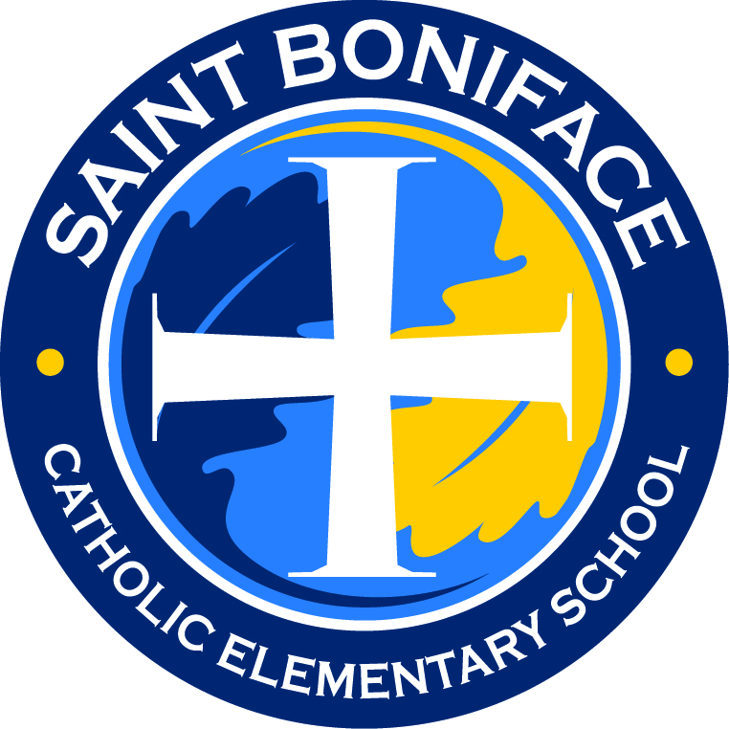
Choose Saint Boniface School:
Fair Share Practice

The Cost of a Catholic Education
One of the questions parents ask when considering a Catholic education for their child is, “Can we afford it?” We understand that the thought of financing a Catholic education can be daunting, but it doesn’t have to be. At Saint Boniface School, it is our mission to make a quality, Catholic education accessible to every Saint Boniface parish family that desires one for their child.

How is this possible? Let’s start with the numbers. Every parish operating a Catholic school has differences in how they finance the cost of the child’s education. Saint Boniface, like most Catholic schools, depends on three basic means to finance this cost:
- Family Investment (Fair Share)
- Parish Investment (Parish subsidies)
- Fundraising

Fair share contributions, parish subsidies and fundraising are equally fundamental to the success of Saint Boniface School. Like a three-legged stool, Saint Boniface depends on the revenue from each of these three components for financial stability. This requires a sacrificial commitment from our families and parishioners, but the benefits to our children are extraordinary.

Fair Share Tuition
In keeping with the teaching of Jesus Christ, Saint Boniface School is committed to enrolling an inclusive and diverse school community. Essential to this policy is our Fair Share model. It is designed to determine each family’s financial contribution according to the principle that a family’s financial investment in their child’s education should be equitable to its financial resources.

Determining Your Financial Investment
Families annually submit a financial commitment to the Principal with their annual registration/enrollment forms. This agreement states what your family’s financial contribution will be towards your child’s tuition. Each family is to prayerfully consider their financial commitment. When determining this amount, we advise families to take into consideration the following factors:
- The cost of education per child for the 2021-2022 school year is $4,150
- Income, savings and other assets
- Desire to pass on the faith to your children
- The value given to education
- Family members, such as grandparents, who would like to support your child’s education
- Any special circumstances in the family

An Investment of Time and Talent
Once your financial investment has been determined, we ask that you consider how much time you are able to invest in your child’s education through volunteering and active participation in your child’s school community. Everyone has gifts from God. We consider your investment of time and talent to be equally important as your financial investment. Our volunteers help keep our education costs low, build a sense of community, and carry out the mission of Christ to serve others. We also ask families to be active and involved members of their parish.

Frequently Asked Questions

WHY SHOULD I CHOOSE SAINT BONIFACE SCHOOL?
Saint Boniface School provides your child with the best and most effective means of an education in the Catholic faith. In addition to a strong faith foundation, children will benefit from small class sizes, excellent academic programming, personal attention and a family atmosphere.

WHAT IF I CAN’T AFFORD THE WHOLE TUITION AMOUNT?
It is very important that a Catholic education is available to all children. It’s OK if you can’t afford to pay the whole tuition amount. The amount is given as a guideline for parents to reference when determining what is a reasonable, yet sacrificial, amount to invest in your child’s Catholic education.

IF I CAN’T AFFORD THE FULL AMOUNT, DO I APPLY FOR FINANCIAL AID OR SCHOLARSHIPS?
No, we trust that the amount families commit to giving, along with parish subsidies and fundraisers, will allow us to provide your child with a quality Catholic education.

HOW DO I KNOW WHAT TO PLEDGE?
Saint Boniface School asks each family to understand that an honest and prayerful financial investment, and sharing of one’s talents assures a quality, Catholic education for all. We ask that the parents’ pledge be a sacrificial and committed financial investment. All families are required to pledge an amount more than zero.

HOW DOES MY PLEDGE FIGURE INTO MY SUNDAY GIVING AT MASS?
Your family’s offertory contributions remain a vital and separate part of the church budget, not to be calculated as part of Fair Share. It is important that the Parish budget remain robust in order to subsidize the school as needed and allow the Fair Share practice to continue.

WHAT IF DURING THE YEAR I DISCOVER THAT I COULD HAVE PLEDGED MORE, OR THAT I CAN NO LONGER AFFORD TO MEET MY PLEDGE?
If your family circumstances have changed, adjustments to your pledge can be made during the school year. Please contact the Principal, Heather Pfannenstein, to make any adjustments.

WHAT IF I AM NOT A MEMBER OF SAINT BONIFACE PARISH?
If families are registered members of another Catholic parish that does not have a Catholic School, those parishes subsidize the children to attend Saint Boniface. Non-Catholic families are very welcome to attend and benefit from the small class sizes, excellent academic programs and Christian teachings. Those families pay the entire cost of education for each child.

